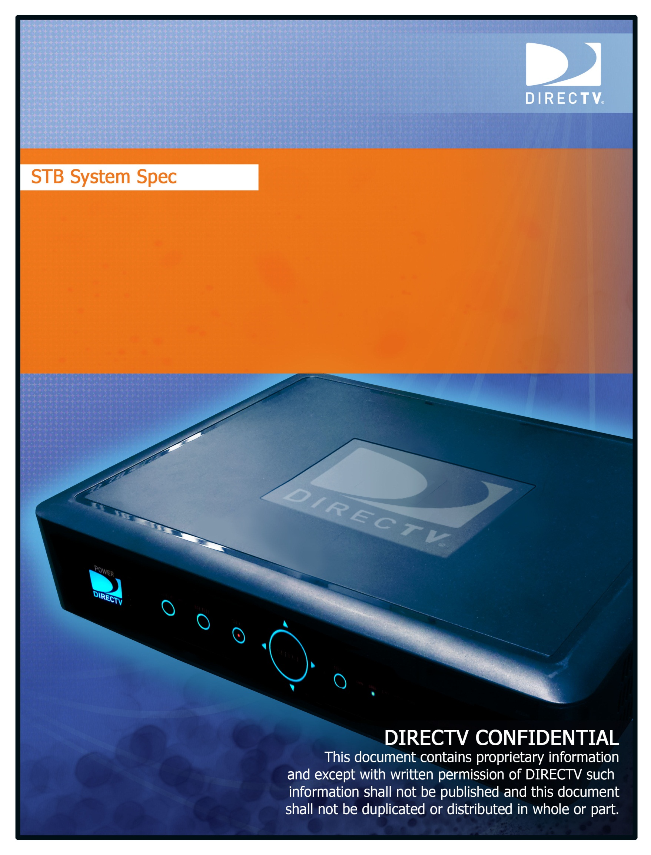

HTML5 Roadmap: JavaScript Video Control

Version 0.1

Aug 19, 2015

# Document Information and Approvals

## Document Information

|  |  |  |  |  |  |
| --- | --- | --- | --- | --- | --- |
| **Author:** |  | **John Sanders** | | | |
|  |  | |  |  |  |
| **CNF/CR#** | CNF-390 | |  | **Doc. Number:** |  |

## Approvals

|  |  |  |  |
| --- | --- | --- | --- |
| **STB Lead*:** |  | **Date:** |  |
| Pankaj Lenka |
| **Test Lead*:** |  | **Date:** |  |
| tbd |
| **Architecture Lead*:** |  | **Date:** |  |
| tbd |

*\* Document must be physically signed by all mandatory approvers.*

Disclaimer

DIRECTV makes no representation, express or implied, that use of the technologies described in this specification will not infringe patents, copyrights, or other intellectual property rights of third parties. Nothing in this specification should be construed as granting permission to use any of the technologies described. Anyone planning to make use of technology covered by the intellectual property rights of others should be first obtain permission from the holder(s) of the rights. This specification is subject to change without notice. DIRECTV, Incorporated, does not accept any responsibility whatsoever for damages or liability, direct or consequential, which may result from use of this specification or any related discussions.

STB Release Matrix

|  |  |  |  |
| --- | --- | --- | --- |
| Software Release | Software Release Date | | Document Ver # |
| TBD |  | 1.0 | |
|  |  |  | |

Table : STB Release Matrix

Revision History

|  |  |  |  |
| --- | --- | --- | --- |
| Author | Ver # | Date | Description |
| J Sanders | 0.1 | 8/19/2015 | Initial draft |
|  |  |  |  |
|  |  |  |  |

Table : Revision History

Table of Contents

Document Information and Approvals 2

1.1 Document Information 2

1.2 Approvals 2

2 References & Terminology 6

2.1 Document References 6

2.2 Glossary 6

3 Feature Overview 7

3.1 Background 7

3.2 In-Scope 7

3.3 Out of Scope 7

3.4 External Systems Impacted (optional) 7

3.5 Supported Hardware Platforms 7

3.6 Assumptions 7

3.7 Risks 8

4 Feature Description 9

4.1 DVR Playback from App 9

4.2 DVR and live Trickplay Control 9

4.3 Lookback Playback 9

4.4 Video UI guidelines 9

4.5 Bonk Sound 10

5 Use Cases 10

5.1 Nominal 10

5.2 Edge Case 12

List of Tables

Table 1: STB Release Matrix 3

Table 2: Revision History 3

Table 3: Reference Documents 6

Table 4: Glossary of Terms 6

# References & Terminology

## Document References

|  |  |  |  |
| --- | --- | --- | --- |
| Ref # | Document # | Doc Version | Document Name |
|  | SCTE-35 | 2015 | Digital Program Insertion Cueing Message for Cable |
|  | SCTE-104 | 2012 | Automation System to Compression System  Communications Applications Program Interface (API) |
|  | DTSS-RS-???? | Ver 1.0 | HTML5 Roadmap Phase 1 and 2  System Specification |
|  |  |  |  |
|  |  |  |  |

Table : Reference Documents

## Glossary

|  |  |
| --- | --- |
| Term | Definition |
| STB | Set-Top-Box |
| OSD | On Screen Display |
| IRD | Integrated Receiver Decoder aka a STB |
|  |  |
|  |  |

Table : Glossary of Terms

# Feature Overview

## Background

This feature will allow HTML5 applications running on WebKit to control all STB video functions. It will include playing live TV, DVR, VOD, C3, MP4 and HLS video and trickplay. The requirements in this section will also define the video UI guidelines.

## In-Scope

Control of the following media formats:

* VOD
* DVR
* C3
* MP4
* HLS

Response of apps to native video commands.

Control of the native “bonk” sound.

## Out of Scope

Functions controlled through SHEF calls, which will remain available as BAU, but may optionally be replaced for video related functions, using the direct JavaScript calls specified in this and the related requirements document [Ref-01]

## External Systems Impacted (optional)

N/A

## Supported Hardware Platforms

Genie HR34, HR44, H44, HR54 and future platforms.

## Assumptions

SHEF commands implementing C3 replay, C3 restart, VOD and DVR playback will be fully delivered in an early phase of HTML5 Roadmap Phase 1 to support the CNN application.

~~There will be no requirement to fully implement HTML5 Video Object control of live, live linear, C3 or VOD.~~

The implementation will include proprietary JavaScript methods closely tied to DIRECTV native functionality.

## Risks

None identified.

# Feature Description

Today the STB terminates HTML apps upon play back of DVR or VOD content, preventing integration of all recorded content, including C3 replay and restart. WebKit should allow apps to play any types of video content or tune channels without app exit.

The WebKit platform will need to communicate all video status – including playout start, playout end, error status and other ongoing status – to the HTML5 app directly through JavaScript without requiring SHEF or polling.

UI guidelines allowing multiple video format support within HTML5 apps will also be covered by the requirements below.

## DVR Playback from App

Apps should have full control over the DVR play back or live buffer, including jumping to any offset. WebKit should provide the size of the live buffer and apps should be able to fast-forward, skip or rewind video.

## DVR and live Trickplay Control

An app will be able to retrieve information relating to buffer size and position and accurately jump to required positions. The app will be able to execute the various trickplay functions.

## Lookback Playback

HTML5 apps should be able to playback Lookback/C3 video within the app. Lookback content playout start time/offset should be configurable.

## Video UI guidelines

Applications will be able to display the trickplay bar and native channel banners, and provide the functionality normally obtained through using these, but focus will not be given to the trickplay bar, so the viewer’s commands do not collide with the app.

## Bonk Sound

Although not a part of video control, control of the “bonk” sound by HTML5 apps is also included in with the video control to provide a home for the single requirement.

# Use Cases

## Nominal

User Case 1: Browsing News Items via App.

1. Customer tunes STB to CNN.
2. STB automatically loads channel-based app for CNN.
3. Through CNN interactive app, customer selects a different news segment, initiating C3   
   restart playback. App does not exit.
4. Through CNN interactive app, customer selects a different news segment, initiating C3   
   replay playback. App does not exit.
5. Through CNN interactive app, customer selects a different news segment, initiating   
   VOD playback. App does not exit.
6. Through CNN interactive app, customer selects a different news segment, initiating   
   DVR playback. App does not exit

User Case 2: Reviewing Sports Event

* 1. Customer has been watching ESPN for one hour.
  2. Customer initiates ESPN channel app.
  3. Customer presses rewind, accessing video within the live linear buffer.
  4. The trickplay bar appears, but does not receive UI focus.
  5. After rewinding 10 minutes of video, customer presses play.
  6. HTML5 app immediately detects current video offset and displays companion   
     interactive content on screen.
  7. After watching video for three minutes, customer chooses new video segment   
     through HTML5 app.
  8. App first checks size of live linear buffer to determine if video segment already   
     recorded on STB.
  9. App determines that video must be accessed through C3 replay. App initiates   
     playback of C3 replay video.
  10. App remains onscreen.

User Case 3: Lookback Playback

1. Customer tunes STB to CNN.
2. STB automatically loads channel-based app for CNN.
3. Through CNN interactive app, customer selects a different news segment, initiating   
   C3 restart playback. App does not exit.
4. Through CNN interactive app, customer selects a different news segment, initiating   
   C3 replay playback. App does not exit.

User Case 4: Channel Banner

1. Viewer is viewing TV augmented with app. Focus is on particular control of the app.
2. Viewer brings up channel banner.
3. Focus moves to banner.
4. Viewer exits banner, focus returns to original control on app.

